**Quantitative Biology Lab – April 29, 2022**

**1. Dimerization kinetics**

You are studying a protein P that forms homodimers:

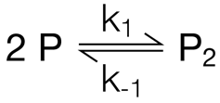

You want to determine the rate constants for dimer formation (k1) and dissociation (k-1­). To that end, you carry out a T jump experiment, measuring the concentration of the monomer, [P], through a change in tryptophane fluorescence upon dimerization (the dimer P2 fluoresces more weakly than the monomer P). The figure below shows the result of the experiment. In this representation, the temperature jump occurs at a time of t = 0 s. We assume here that the temperature change happens instantaneously.

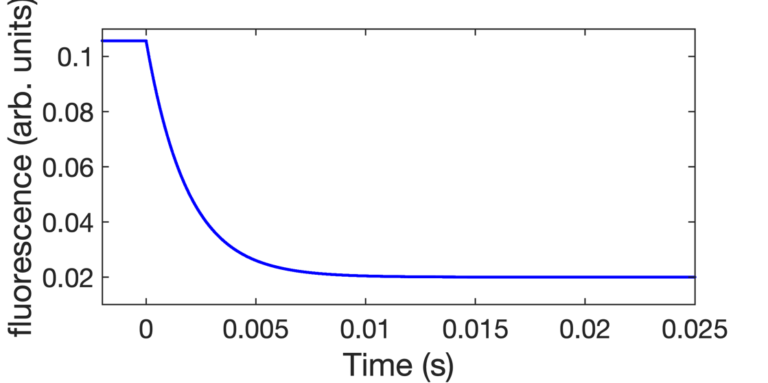

**1.1** Immediately after the T jump, the concentration of P starts to decrease. This decrease is caused by the instantaneous change in one parameter of the system. What parameter changes at t = 0, how does this parameter change (increase vs. decrease) in this example, and why does this change result in a change in the concentration of P?

The **equilibrium constant** increases. This means that the product becomes more favored, so [P] decreases as it dimerizes to become P2.

**1.2** Provide an equation that describes this curve and relates the observed signal to the two rate constants k1 and k­-1 (as discussed in class).

Given that the total fluorescence F at any given point should be given by F = α[P1] + β[P2], where α and β are the fluorescence/M values of P1 and P2 respectively, then we can calculate equations over time for [P1] and [P2]:

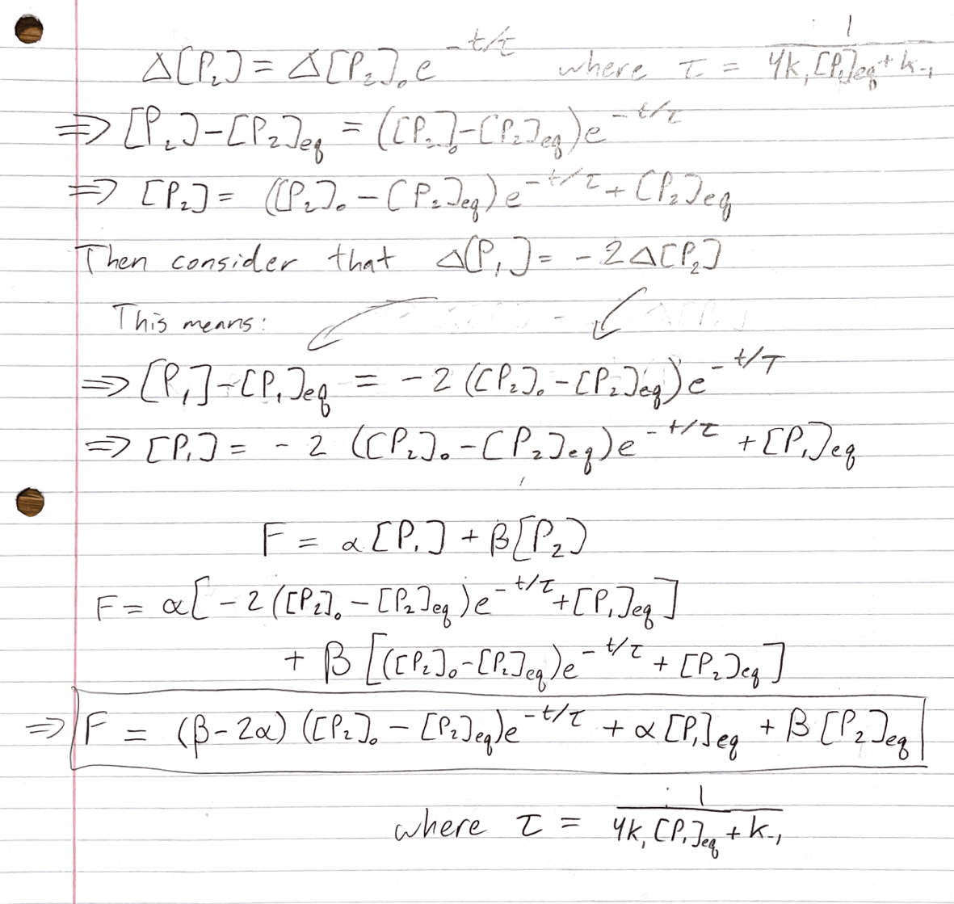

**1.3** If you know the dimer dissociation constants at the temperatures before and after the jump and the total protein concentration ([P]0), can you determine both rate constants (k1 and k-1) from a single experiment? Choose ‘yes’ or ‘no’ and explain your answer.

If you know the value of α and β then yes, you can determine both rate constants with the given information. This is because the given information is sufficient to determine all the constants in the above equation besides the rate constants k1 and k-1. Given that KD = k-1 / k1, then this fact and the above equation give us a system of two orthogonal equations with two unknown values, and such a system is solvable. Note: if we do not know the values α and β, then this is not solvable.

**2. Enzyme kinetics**

A substrate S binds to an enzyme E with a rate constant of 108 M-1 s-1. The rate constant for substrate dissociation from the enzyme is 100 s-1, and the turnover number is 5000 s-1.

**2.1** Calculate the Michaelis constant (KM), the initial velocity (v0), the catalytic efficiency and the fractional occupancy of the enzyme at a total substrate concentration of 1 µM and an enzyme concentration of 1 nM. Make sure to include units with your results.

Km = (k-1+k2)/k1 = (k-1+kcat)/k1 = (100 + 5000)/108 = **5.1x10-5 M**

v0 = vmax * [S] / (Km + [S]) = kcat­ * [E]0 * [S] / (Km + [S]) = 5000 * 10-9 * 10-6 / (5.1E-5 + 10-6) = **9.62x10-8 M/s**

cat. efficiency = kcat / Km = 5000 / 5.1E-5 = **9.80x107 M-1s-1**

Frac. occupancy = [S] / (Km + [S]) = 10-6 / (5.1E-5 + 10-6) = **1.92x10-2 (unitless)**

For some enzymes, an increase in catalytic efficiency results in higher fitness of an organism. Mutations that increase the substrate binding rate, decrease the substrate dissociation rate or increase catalytic rate all have the potential to increase the catalytic efficiency of an enzyme.

**2.2** A mutation in the enzyme increases the catalytic rate constant of the enzyme 10-fold relative to the wild-type enzyme (all other parameters stay the same). How do the values calculated in 2.2 change?

Km would increase nearly 10-fold. However, v0 would not change much and the catalytic efficiency would stay exactly the same. Fraction occupancy would decrease nearly 10-fold.

**2.3** A mutation in the enzyme decreases the rate constant for substrate dissociation 10-fold relative to the wild-type enzyme (all other parameters stay the same). How do the values calculated in 2.2 change?

K­m would remain relatively unchanged (5.1E-5 in the WT vs. 5.01E-5 in the mutant), and this means the values for all the other calculated values would remain relatively the same as well. This happens because kcat is relatively large compared to k-1 in both the WT and mutant case.

**2.4** Why might it not be possible for a mutation to increase the rate constant for substrate binding? (Hint: think about what fundamentally limits this parameter.)

Binding is mostly limited by diffusion speed, which is itself influenced by molecule size and the temperature. Because single mutations cannot drastically alter the diffusion speed of an enzyme, it is unlikely for mutations to increase the substrate binding rate.

**2.5** The figure below shows velocity measurements for an enzymatic reaction at 4 different substrate concentrations (panel A). Explain how each of these measurements is represented in the Michaelis-Menten plot on the right (panel B).

The calculated slope vi for each line is an estimated v0 for the substrate concentration [S] that is present at t = 1 minute. The calculation v1 is relatively small, so this falls on the line in Panel B at low [S] and low v0­. The calculations v­2, v3, and v4 are increasing in value, ending with v4  which will lie at a high [S] and v0 on the line in Panel B.

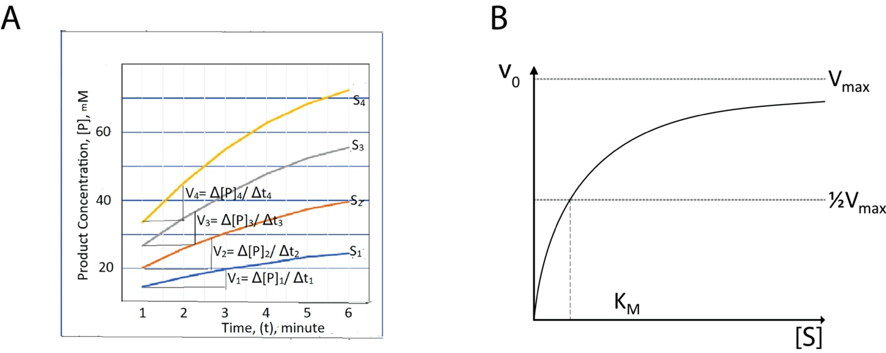

**3. Enzyme inhibition**

You measure the initial velocities, v0, of an enzyme-catalyzed reaction at several different substrate concentrations. For each substrate concentration, you obtain v0 in the absence and presence of an inhibitor of the enzyme. All other reaction conditions are kept constant.

|  |  |  |
| --- | --- | --- |
| [S] (µM) | v0 (µM s-1) | |
| - inhibitor | + inhibitor |
| 0.3 | 0.127 | 0.099 |
| 1 | 0.353 | 0.198 |
| 3 | 0.720 | 0.277 |
| 10 | 1.132 | 0.322 |
| 30 | 1.353 | 0.337 |

**3.1** Prepare a Lineweaver-Burk plot of both data sets at fit a linearized Michaelis-Menten model to the data. You can use any software to fit/plot the data. The plots should show the individual data points as well as an appropriate fit. Make sure to label the axes, including units, and report the fitting parameters that you obtain.

**3.2** Calculate the values for Vmax and KM in the presence and absence of inhibitor.

**3.3** Which of the following inhibition mechanisms best describes how the inhibitor acts? Select one answer and explain your reasoning.

a. competitive inhibition

b. non-competitive inhibition

**c. substrate-dependent non-competitive inhibition**

We know this because the Lineweaver-Burke plot is shifted but the slope stays the same, which is characteristic of substrate-dependent non-competitive inhibition.

**3.4** What is the inhibitor concentration if the inhibition constant for this inhibitor is 750 µM?

My calculations are at the end of my jupyter notebook. My final answer was 2.494 millimolar.